SQL QUERIES
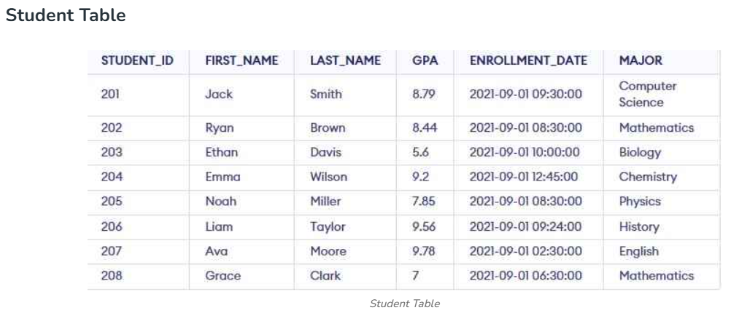
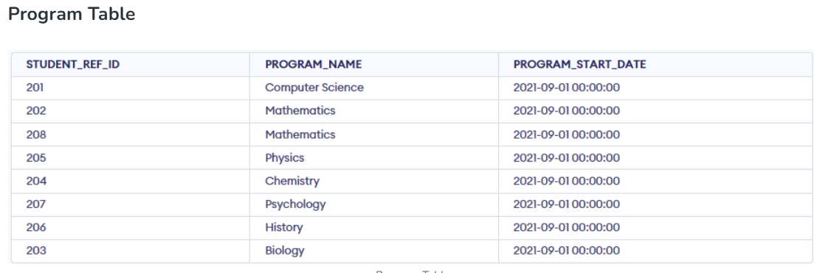
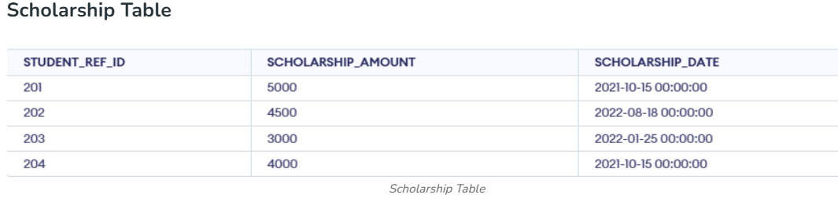
1. Write a SQL query to fetch "FIRST_NAME" from the Student table in upper case and use ALIAS name as STUDENT_NAME.
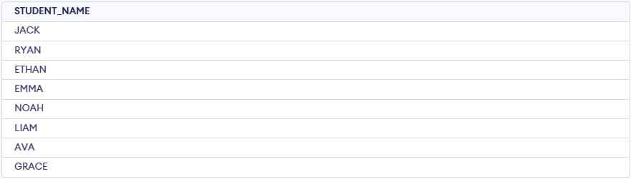
- Converts first names to uppercase using UPPER().
- Displays the result as STUDENT_NAME.

2. Write a SQL query to fetch unique values of MAJOR Subjects from Student table.
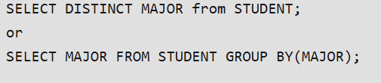
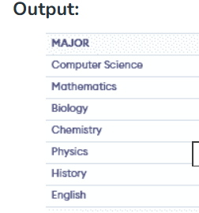
- Retrieves unique values from the MAJOR column.
- Removes duplicate majors using DISTINCT.

3. Write a SQL query to print the first 3 characters of FIRST_NAME from Student table.

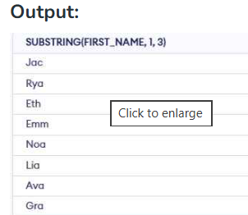
- Extracts the first 3 characters from FIRST_NAME.
- Uses the SUBSTRING() function.

4. Write a SQL query to find the position of alphabet ('a') int the first name column 'Grace' from Student table.
- Finds the position of the first occurrence of 'a'.
- For Grace, 'a' is at position 3.

5. Write a SQL query that fetches the unique values of MAJOR Subjects from Student table and print its length.
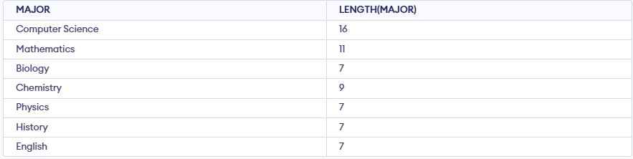
- Groups records by MAJOR.
- Calculates the length of each major using LENGTH().
6. Write a SQL query to print FIRST_NAME from the Student table after replacing 'a' with 'A'.
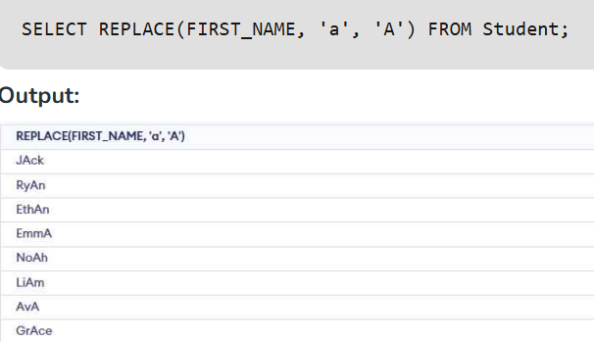
- Replaces 'a' with 'A' in FIRST_NAME.
- Affects only names containing 'a'.

7. Write a SQL query to print the FIRST_NAME and LAST_NAME from Student table into single column COMPLETE_NAME.
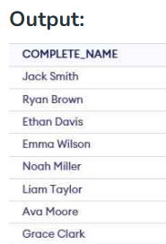
- Combines FIRST_NAME and LAST_NAME into a single column.
- Displays the result as COMPLETE_NAME.

8. Write a SQL query to print all Student details from Student table order by FIRST_NAME Ascending and MAJOR Subject descending .
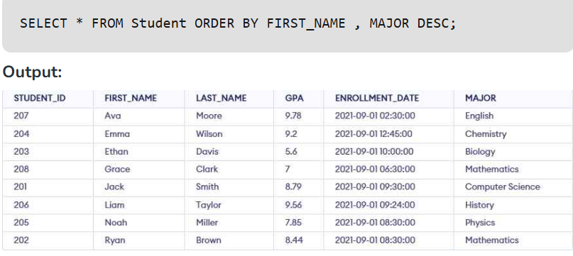
- Sorts records by FIRST_NAME in ascending order.
- Then sorts by MAJOR in descending order.

9. Write a SQL query to print details of the Students with the FIRST_NAME as 'Noah' and 'Ava' from Student table.
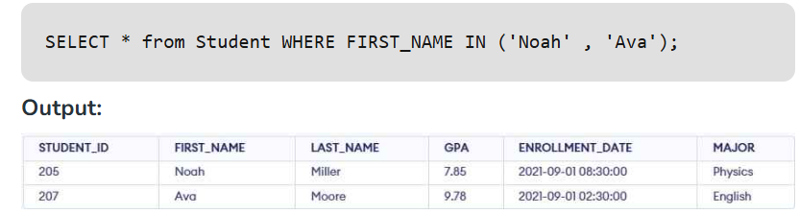
- Retrieves rows where FIRST_NAME is Noah or Avah.
- Uses the IN operator to match multiple values.

10. Write a SQL query to print details of the Students excluding FIRST_NAME as 'Jack' and 'Liam' from Student table.
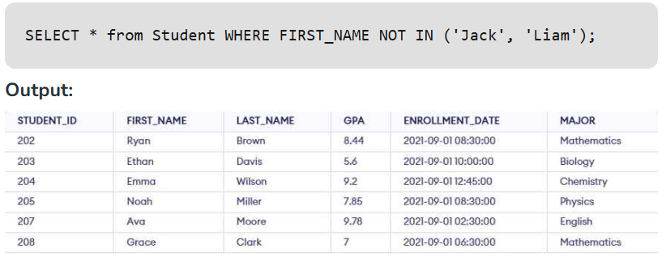
- Excludes rows where FIRST_NAME is Jack or Liam.
- Uses the NOT IN operator to filter records.

11.Write a SQL query to print details of the Students whose FIRST_NAME ends with 'a'.
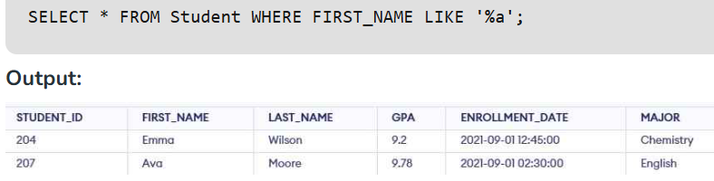
- Retrieves names ending with 'a'.
- Uses %a with the LIKE operator to match the pattern.

12. Write an SQL query to print details of the Students whose FIRST_NAME ends with ‘a’ and contains five alphabets.
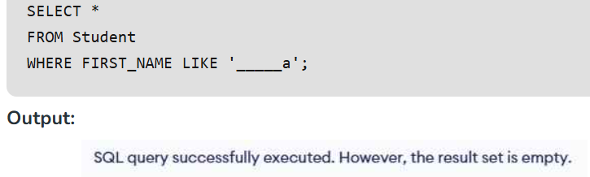
- Searches for names with exactly 5 characters ending in 'a'.
- No records match this condition, so the result is empty.

13. Write an SQL query to print details of the Students whose GPA lies between 9.00 and 9.99.
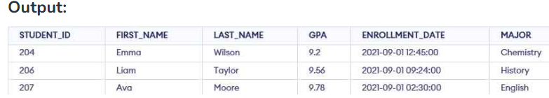
- Retrieves students with GPA between 9.00 and 9.99.
- Uses the BETWEEN operator to filter records.

14. Write an SQL query to fetch the count of Students having Major Subject ‘Computer Science’.
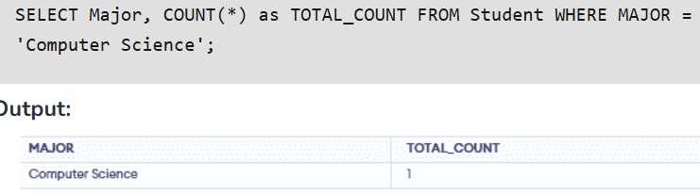
- Counts the number of students in Computer Science.
- Returns the total using COUNT(*).

15. Write an SQL query to fetch Students full names with GPA >= 8.5 and <= 9.5.
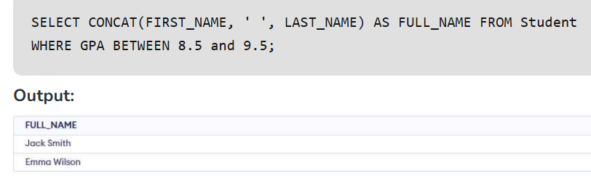
- Combines FIRST_NAME and LAST_NAME into a full name.
- Displays students with GPA between 8.5 and 9.5.

16. Write an SQL query to fetch the no. of Students for each MAJOR subject in the descending order.
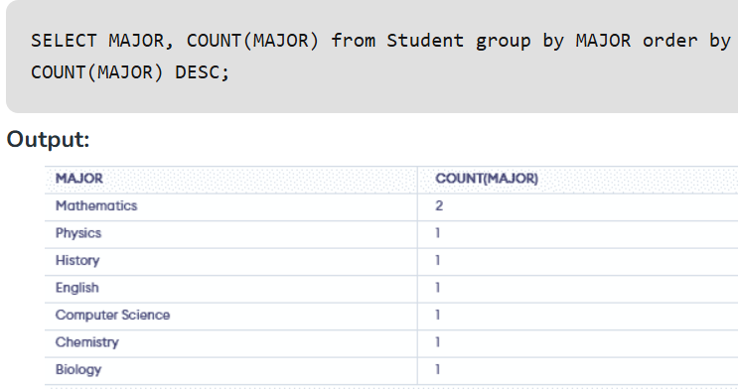
- Groups students by MAJOR.
- Counts students in each major using COUNT(*).
- Sorts the result by student count in descending order.

17. Display the details of students who have received scholarships, including their names, scholarship amounts and scholarship dates.
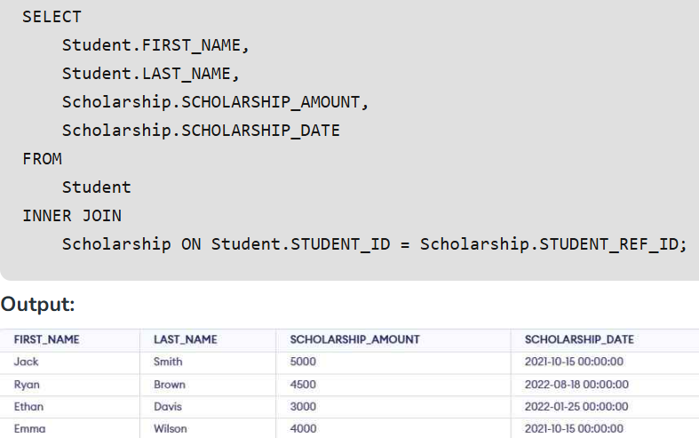

- Joins the Student and Scholarship tables using INNER JOIN.
- Displays students who received scholarships along with their scholarship details.

18. Write an SQL query to show only odd rows from Student table.
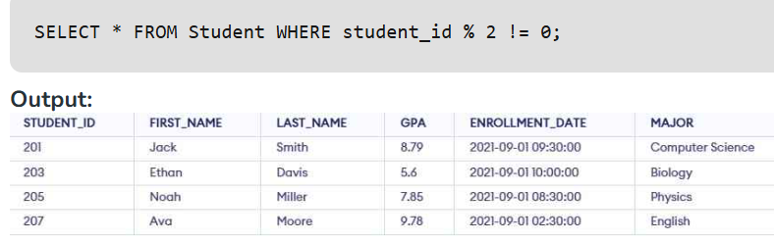
- Filters records with odd STUDENT_ID values.
- Uses the condition STUDENT_ID % 2 != 0.

19. Write an SQL query to show only even rows from Student table
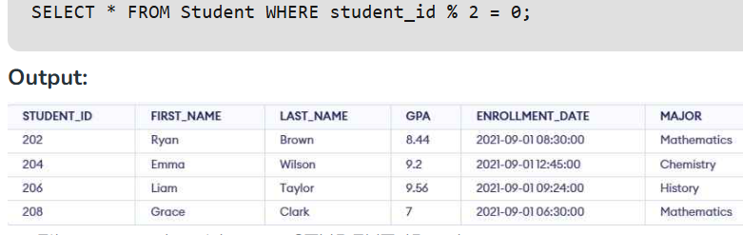
- Filters records with even STUDENT_ID values.
- Uses the condition STUDENT_ID % 2 = 0.

20.List all students and their scholarship amounts if they have received any. If a student has not received a scholarship, display NULL for the scholarship details.
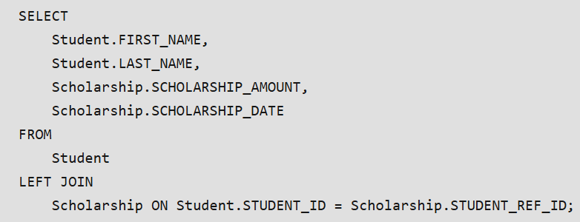
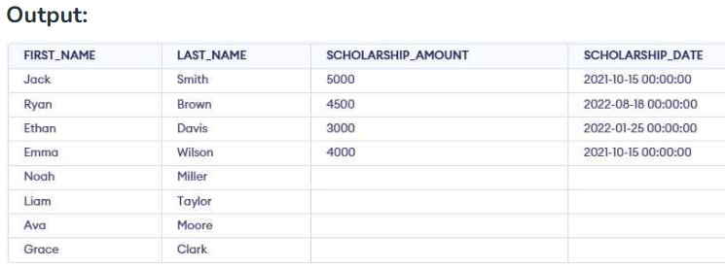
- Retrieves all students using LEFT JOIN.
- Shows NULL for scholarship details if a student has not received a scholarship.

21. Write an SQL query to show the top n (say 5) records of Student table order by descending GPA.
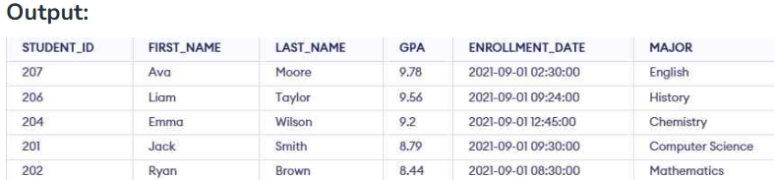
- Sorts students by GPA in descending order.
- Displays the top 5 students with the highest GPA.

22. Write an SQL query to determine the nth (say n=5) highest GPA from a table.
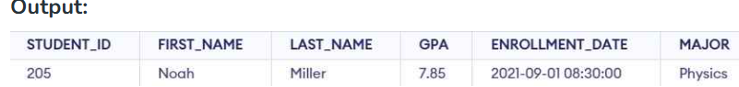
- Skips the first 4 records and retrieves the 5th record.
- Uses LIMIT and OFFSET for row selection.

23. Write an SQL query to determine the 5th highest GPA without using LIMIT keyword.’
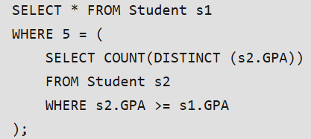
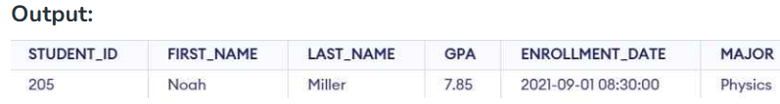
- Finds the 5th highest GPA.
- Uses a correlated subquery to rank GPAs.

24. Write an SQL query to fetch the list of Students with the same GPA.
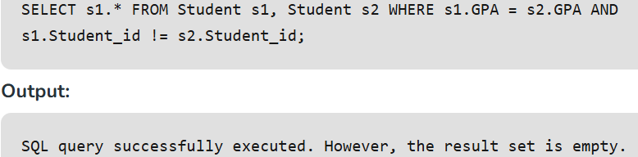
- Identifies students with the same GPA.
- Uses a self-join and excludes matching the same student.

25. Write an SQL query to show the second highest GPA from a Student table using sub-query.
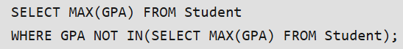
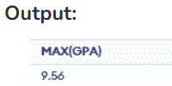
- Finds the second highest GPA.
- Excludes the highest GPA using a subquery.
26. Write an SQL query to show one row twice in results from a table.
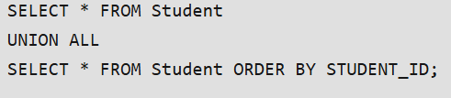
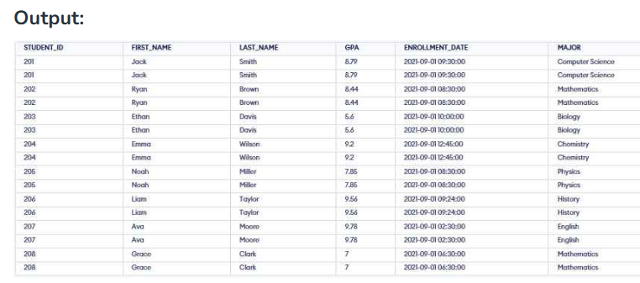
- Combines results from two queries using UNION ALL.
- Includes duplicate rows and sorts them by STUDENT_ID.

27. Write an SQL query to list STUDENT_ID who does not get Scholarship.
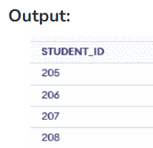
- Identifies students who have not received a scholarship.
- Uses the NOT IN operator to exclude scholarship recipients.

28. Write an SQL query to fetch the first 50% records from a table.
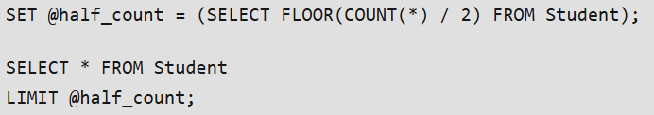
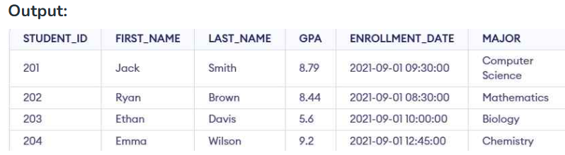
- Counts the total number of records in the table.
- Retrieves the first 50% of records using LIMIT.

29. Write an SQL query to fetch the MAJOR subject that have less than 4 people in it.
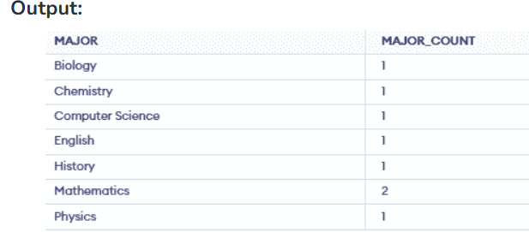
- Groups students by MAJOR.
- Displays majors having fewer than 4 students.

30. Write an SQL query to show all MAJOR subject along with the number of people in there.
’
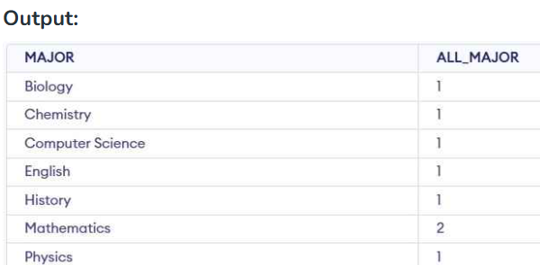
This query groups students by their MAJOR and counts the number of students in each group. It provides a breakdown of how many students are enrolled in each major.

31. Write an SQL query to show the last record from a table.
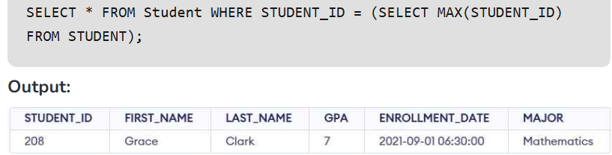
- Retrieves the last record from the Student table.
- Uses the maximum STUDENT_ID to identify the latest record.

32. Write an SQL query to fetch the first row of a table.
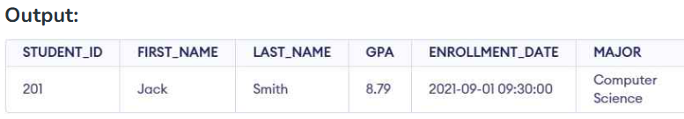
- Retrieves the first record from the Student table.
- Uses the minimum STUDENT_ID to identify the first entry.

33. Write an SQL query to fetch the last five records from a table.
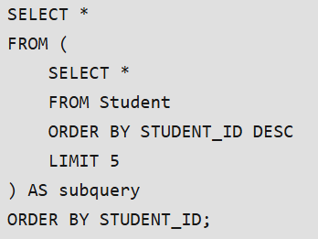
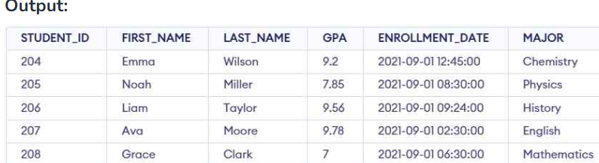
- Retrieves the last 5 records from the table.
- Reorders them in ascending STUDENT_ID order.

34. Write an SQL query to fetch three max GPA from a table using co-related subquery.
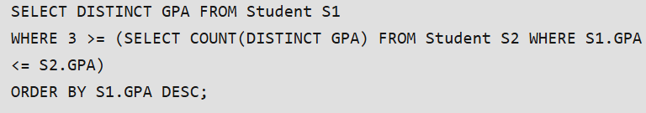
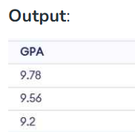
- Retrieves the top 3 highest distinct GPAs.
- Uses a subquery to rank GPAs based on their values.

35. Write an SQL query to fetch three min GPA from a table using Correlated subquery.
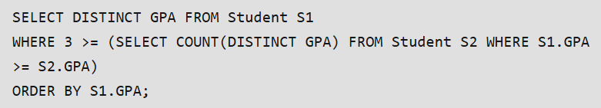
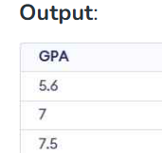
- Retrieves the bottom 3 lowest distinct GPAs.
- Uses a subquery to rank GPAs in ascending order.

36. Write an SQL query to fetch second max GPA from a table.
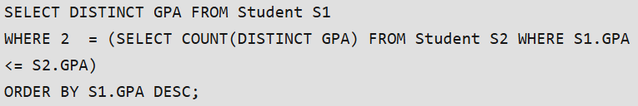
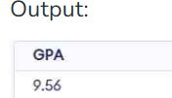
- Finds the 2nd highest GPA.
- Uses a correlated subquery to rank GPAs.

37. Write an SQL query to fetch MAJOR subjects along with the max GPA in each of these MAJOR subjects.
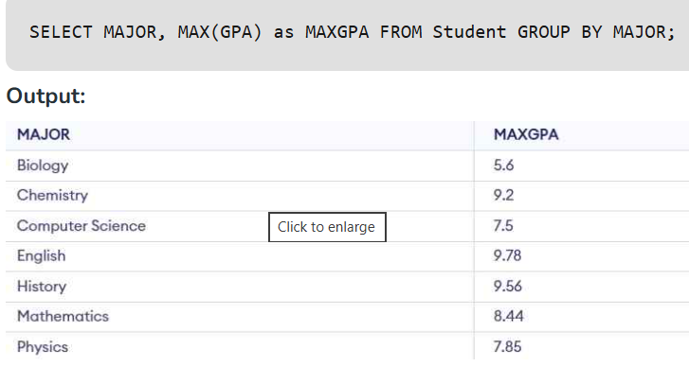
- Groups students by major.
- Finds the highest GPA in each major using MAX().

38. Write an SQL query to fetch the names of Students who has highest GPA.
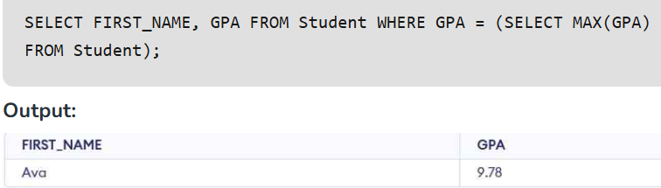
- Finds the student(s) with the highest GPA.
- Uses a subquery to get the maximum GPA.

39. Write an SQL query to show the current date and time.
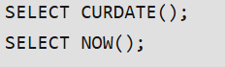
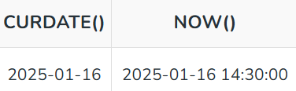
- CURDATE() returns the current date.
- NOW() returns the current date and time.

40. Write a query to create a new table which consists of data and structure copied from the other table (say Student) or clone the table named Student.
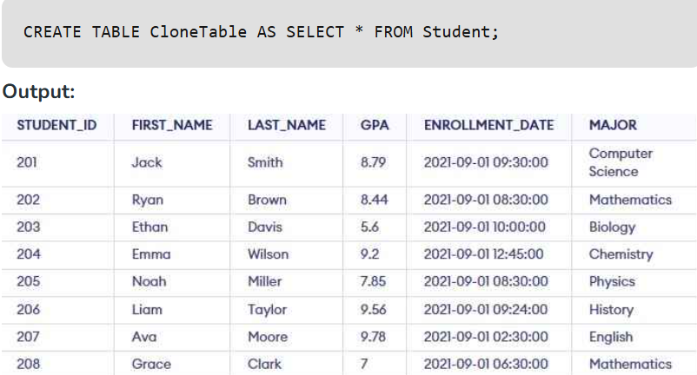
This query creates a new table CloneTable that contains the same structure and data as the Student table. It is a simple way to back up or duplicate a table for testing or other purposes.

41. Write an SQL query to update the GPA of all the students in 'Computer Science' MAJOR subject to 7.5.
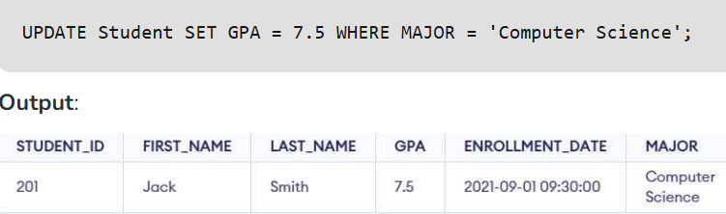
- Updates the GPA of Computer Science students to 7.5.
- Uses the UPDATE statement with a WHERE clause.

42. Write an SQL query to find the average GPA for each major.
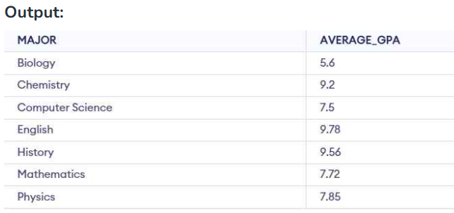
- Calculates the average GPA for each major.
- Groups the results by major.

43. Write an SQL query to show the top 3 students with the highest GPA.
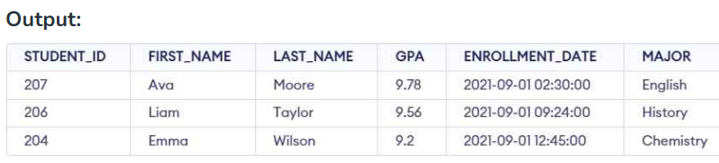
- Sorts students by GPA in descending order.
- Displays the top 3 students with the highest GPA.

44. Write an SQL query to find the number of students in each major who have a GPA greater than 7.5.
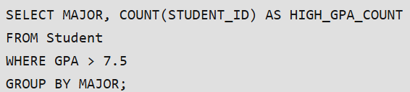
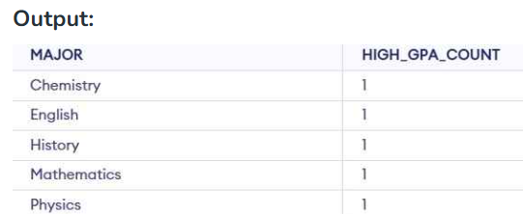
- Filters students with GPA greater than 7.5.
- Groups the students by major.
- Counts the number of students in each major.

45. Write an SQL query to find the students who have the same GPA as 'Jack Smith'.
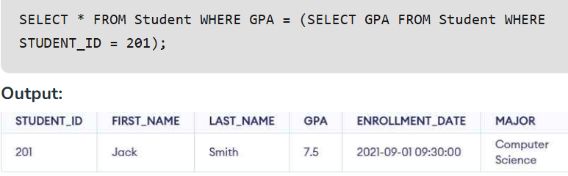
Displays students having the same GPA as Jack Smith. If no one else shares it, only Jack Smith is returned.

46: Delete duplicate data from table only first data remains constant.
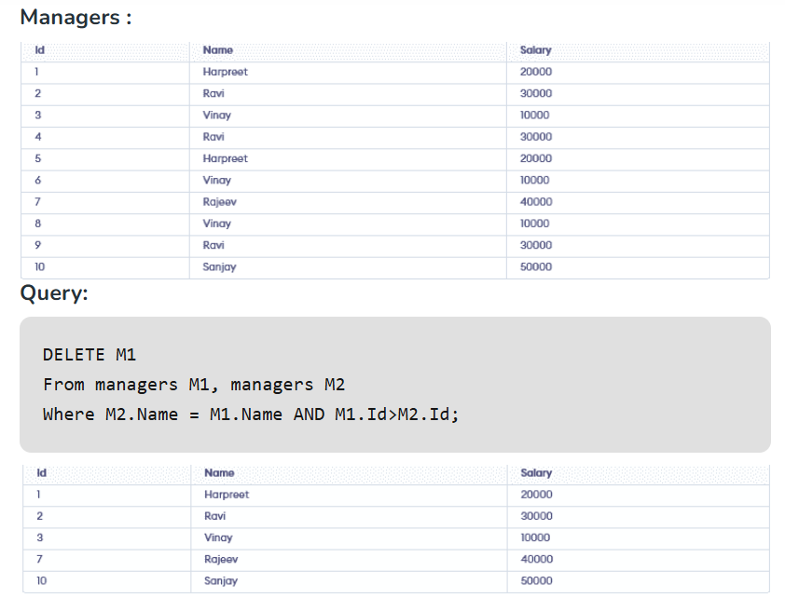

47 : Find the employee name using COALESCE() when First_Name, Second_Name, or Last_Name may contain NULL values.
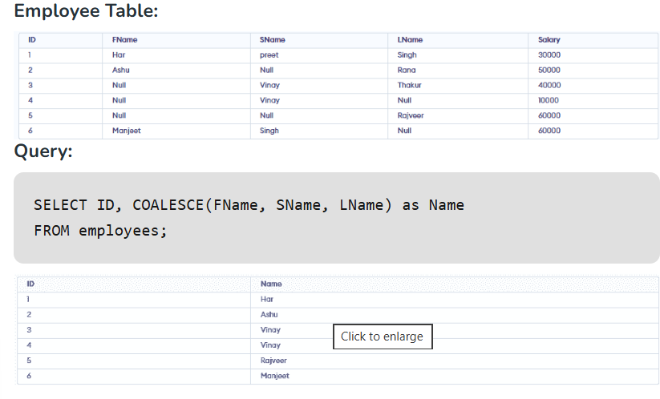

48: Find employees hired in the last n months using the TIMESTAMPDIFF() function.
